**SOFTWARE REQUIREMENT SPECIFICATION**

**DOCUMENT**

**LIBRARY MANAGEMENT SYSTEM**

**Version:** Version 2.0



**ABSTRACT**

This document is intended to be the SRS for develop **CALCULATOR SYSTEM**



| **Project Title** | **CALCULATOR SYSTEM** | | |
| --- | --- | --- | --- |
| **Lead Institution** | **THE INTERNATIONAL SCHOOL - DUY TAN UNIVERSITY** | | |
| **Project Mentor** | **Mr. Nguyen Dang Quang Huy** | | |
| **Team Name** | **Team 3** | | |
| **Team Members** | **Nguyễn Quang Thông** | | |
| **Mai Hoàng Tùng** | | |
| **Trần Quốc Hoàng** | | |
| **Phạm Ngọc Trung** | | |
| **Phan Quang Trung** | | |
| **Start Date** | Jan 25,2024 | **End Date** | Jan 31,2024 |

**ROPRIETARY INFORMATION**: The information contained in this document is the property of **TEAM 3**. Except as specifically authorized in writing by **TEAM 3**, the holder of this document shall keep all information contained herein confidential and shall protect same in whole or in part from disclosure and dissemination to all third parties

**Table of Contents**

Revision History 4

1. Introduction 6

1.1. Purpose 6

1.2. Intended Audience and Reading Suggestions 6

1.3. References 6

2. Project Overview 6

2.1. Project Description 6

2.2. Business Need 7

2.3. Project Analyst 7

2.3.1. Business Function Diagram 7

2.3.2. System Context Diagram 8

2.3.3. Data Flow Diagram 9

2.4. Software Requirement Specification 11

2.4.1. High level Fucntional Requirement (FR) 11

2.4.2. Stakeholders 13

2.4.3. Usecase 14

2.4.3.1. <<Library Management>> Use Case Diagram Overview 15

2.4.4. List of use cases 15

2.4.5. Use Case Specification 15

*UC 01: Login* 15

*UC 02: Search books* ....17

*UC 03: Borrow books* 18

*UC 04: Manage books* 20

*UC 05: Receive return books* 22

*UC 06: Manage readers* 24

*UC 07: Search information about readers* 25

*UC 08: Statistical report on borrowing books* 26

*UC 09: Make a reader card* 28

*UC 10: Card renewal for readers* 29

*UC 011: Reader statistics report* 31

*UC 012: Report ,statistics of books received* 33

2.4.6. Software Quality Attributes 35

2.4.6.1. Usability 35

2.4.6.2. Reliability 35

2.4.6.3. Security 35

2.4.6.4. Maintainability 35

2.4.6.5. Portability 35

2.4.6.6. Performance 35

2.5. Software Design Description 36

2.5.1. Sequence Diagrams 36

2.5.1.1.

2.5.1.2.

2.5.2. Activity Diagrams 42

2.5.2.1.

2.5.3. Class Diagram 51

Appendix A: Glossary 51

# Revision History

| **Date** | **Change Iterm** | **Description** | **by** | **Version** |
| --- | --- | --- | --- | --- |
| **25/01/2024** | Get requests from customers | After preparing the questions about the request and received the request from the customer | Nguyễn Quang Thông, Trần Quốc Hoàng | Version 1.0 |
| **26/01/2024** | Start team meeting | Meet and refer to a number of training points, read through the training points and focus on project implementation, the team can fully understand the system requirements to create | Nguyễn Quang Thông, Trần Quốc Hoàng, Mai Hoàng Tùng, Phạm Ngọc Trung, Phan Quang Trung | Verison 1.0 |
| **26/01/2024** | Job analysis | Through specific requirements, analysis, clearly speaking, the leader needs to prepare in advance for the members. | Nguyễn Quang Thông | Verison 1.0 |
| **26/01/2024** | Share the work | Get BFD, contextual diagram, DFD level 1, DFD level 2,  The mandatory rules of the project | Nguyễn Quang Thông, Trần Quốc Hoàng | Verision 1.0 |
| **26/01/2024** | Editing group | BFD, DFD, USE CASE, Context Diagram, font size, font | Nguyễn Quang Thông, Trần Quốc Hoàng | Verision 1.0 |
| **27/01/2024** | Complete DFD, System Context Diagram | DFD 1 and 2, System Context Diagram | Nguyễn Quang Thông, Trần Quốc Hoàng | Verision 2.0 |

# Introduction

## Purpose

This documentation describes a library management system including all needed information and feature materials in detail for implementation. The purposes of this document are as below:

* To supports the project manager having an overview of the system as well as doing project estimation
* To describes the architectural drivers and use cases in details. Based on this document, architect analyst and designer will be able to implement the system easily.
* To supports tester (QC) writing acceptance test and test plan.

## Intended Audience and Reading Suggestions

| Intended Audience | Reading Suggestions |
| --- | --- |
| Project manager | High level functional requirement, business constraints for estimation |
| Architect analyst and designer | Overall description and user cases to architect and design the system |
| Quality control | Overall description and user cases to make test plan and write acceptance test |
|  |  |

## References

# Project Overview

## Project Description

## Information Technology has revolutionized the life of human beings and has made lives easier by the various kinds of applications. In the light of the rapid changes with the use of Information Technology, there are many tools,technologies and systems that have been produced and invented.

## This project is concerned with developing a Calculator System for Duy Tan student in order to make calculating more efficient and easy to handle. The Calculator system enables a fully automated calculated service. The goal of this project is to create a program that takes two input numbers, denoted as 'a' and 'b', and performs basic arithmetic operations on them.

## Business Need

This system had a number of advantages:

- Users can easily perform basic arithmetic operations with just a few simple steps, providing a convenient and user-friendly experience.

- Supports various basic operations such as addition, subtraction, multiplication, and division, offering flexibility for users in performing different types of calculations.

- The source code is designed for easy maintenance and scalability, making it straightforward for developers to add new features or fix issues when needed.

- Easy-to-use interface.

## Project Analyst

### Business Function Diagram

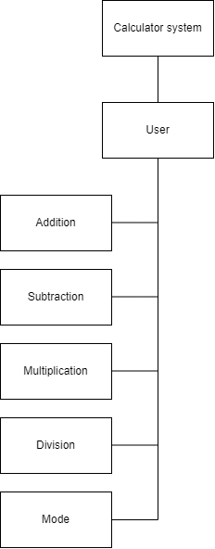

### System Context Diagram

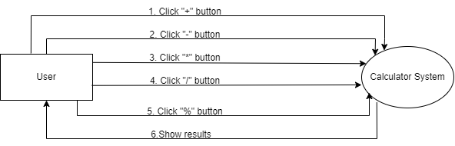

## Software Requirement Specification

### High level Functional Requirement (FR)

| FR1 | **Title** | **Addition** |
| --- | --- | --- |
| **User** | Actor uses this Use Case to perform adding two arbitrary numbers within the system. |
| Description | The input for this function typically consists of two numbers, commonly referred to as "a" and "b," representing the values to be added. The operation of the function is straightforward: the values of "a" and "b" are summed together, creating a total, and subsequently, this sum is returned for use or display on the screen. The simplicity of the function lies in the fact that it takes two numerical inputs and produces a result by adding them. This fundamental arithmetic process is a core element in both mathematics and programming. |
| FR2 | **Title** | **Subtraction** |
| User | Actor uses this Use Case to perform subtracting two arbitrary numbers within the system. |
| Description | In this case, it takes two numerical values, typically denoted as "a" and "b," where "a" is the minuend (the number to be subtracted from) and "b" is the subtrahend (the number to be subtracted). |
| FR3 | **Title** | **Multiplication** |
| User | Actor uses this Use Case to perform multiplicating two arbitrary numbers within the system. |
| Description | The multiplication function is designed to carry out the arithmetic operation of multiplying two numbers. It takes two numerical values, conventionally denoted as "a" and "b," where "a" represents the multiplicand, and "b" represents the multiplier. |
| FR4 | Title | **Division** |
| User | Actor uses this Use Case to perform divising two arbitrary numbers within the system. |
| Description | The division function is designed to perform the arithmetic operation of dividing one number by another. It takes two numerical values, typically denoted as "a" and "b," where "a" is the dividend (the number to be divided) and "b" is the divisor (the number by which "a" is divided). |
| FR5 | Title | **Mod** |
|  | User | Actor uses this Use Case to perform moding two arbitrary numbers within the system |
|  | Description | The modulo division function calculates the remainder when one number is divided by another. It takes two numerical values, conventionally denoted as "a" and "b," where "a" is the dividend and "b" is the divisor. |

### Stakeholders

| **Stakeholder** | **Description** |
| --- | --- |
| Users | System users |

### Use case

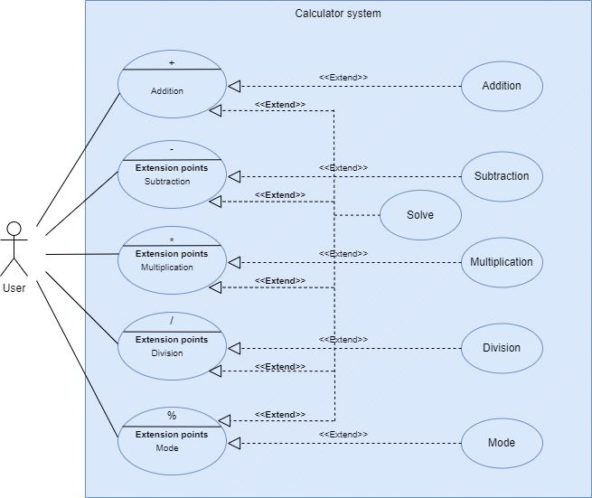

### List of use case

| **Use case ID** | **Use case name** | **Functional Req.** |
| --- | --- | --- |
| UC.01 | Addition | FR.1 |
| UC.02 | Subtraction | FR.2 |
| UC.03 | Multiplication | FR.3 |
| UC.04 | Division | FR.4 |
| UC.05 | Mode | FR.5 |

**2.4.5.Use Case Specification**

##### UC 01:Addition

1. Use Case Diagram

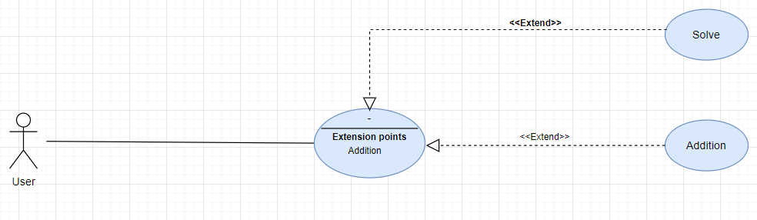

1. Use Case Specification

| Use case ID | UC.01 | | | | |
| --- | --- | --- | --- | --- | --- |
| Use case name | **Cộng 2 số bất kỳ** | | | | |
| Create by | Nguyễn Quang Thông | | **Last updated by** | | Nguyễn Quang Thông |
| Date created | Jannuary 26, 2024 | | **Date last updated** | | January 27, 2024 |
| Actor | Users of the system | | | | |
| Description | This Use Case describes the process of adding two arbitrary numbers within the system. | | | | |
| Trigger | Access to the system interface successfully | | | | |
| Pre-condition | **Both values entered are numeric** | | | | |
| Post-condition | If the use case is successful, the system displays the result of adding the two numbers on the user interface. | | | | |
| Main Success | **Step** | **Actor Action** | | **System Response** | |
| Scenario | 1 | Press the "addition" button | | 2. The system displays a box for the user to enter 2 numbers | |
| 3 | The user enters 2 numbers into the box | | 4. The system confirms the number the user entered | |
| 5 | Press the "solve" button | | 6. Check the correct data type, the system displays the results to the user | |
| 7 |  | | 8. Display the total results on the screen | |
| Exception | **Step** | **Actor Action** | | **System Response** | |
|  |  | | 6.1 If the data type is checked incorrectly, the system will notify the error and let the user re-enter the number. | |
| Priority | High | | | | |
| Business rule | N/A | | | | |
| Description: | The addition function for two numbers is a fundamental mathematical and programming operation used to increase the value of two numbers together. The main purpose of addition is to aggregate the values of the given numbers. | | | | |

##### 

##### UC.02: Subtraction

a) Use Case Diagram

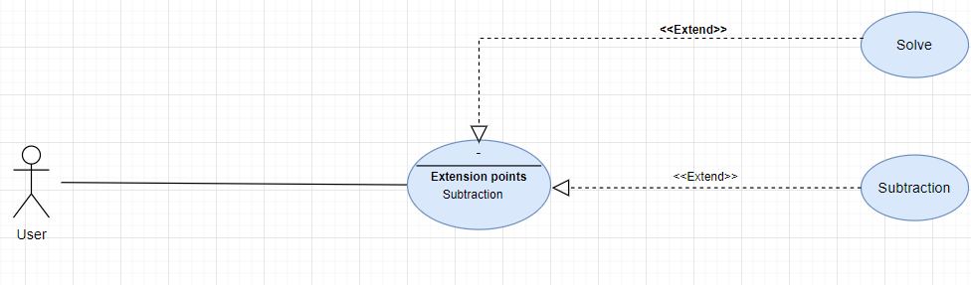

b) Use Case Specification

| Use case ID | UC.02 | | | | |
| --- | --- | --- | --- | --- | --- |
| Use case name | **Trừ 2 số bất kỳ** | | | | |
| Create by | Nguyễn Quang Thông | | **Last updated by** | | Nguyễn Quang Thông |
| Date created | Jannuary 26, 2024 | | **Date last updated** | | January 27, 2024 |
| Actor | Users of the system | | | | |
| Description | This Use Case describes the process of adding two arbitrary numbers within the system. | | | | |
| Trigger | Access to the system interface successfully | | | | |
| Pre-condition | **Both values entered are numeric** | | | | |
| Post-condition | If the use case is successful, the system displays the result of adding the two numbers on the user interface. | | | | |
| Main Success | **Step** | **Actor Action** | | **System Response** | |
| Scenario | 1 | Press the "Subtraction" button | | 2. The system displays a box for the user to enter 2 numbers | |
| 3 | The user enters 2 numbers into the box | | 4. The system confirms the number the user entered | |
| 5 | Press the "solve" button | | 6. Check the correct data type, the system displays the results to the user | |
| 7 |  | | 8. Display the total results on the screen | |
| Exception | **Step** | **Actor Action** | | **System Response** | |
|  |  | | 6.1 If the data type is checked incorrectly, the system will notify the error and let the user re-enter the number. | |
| Priority | High | | | | |
| Business rule | N/A | | | | |
| Description: | The addition function for two numbers is a fundamental mathematical and programming operation used to increase the value of two numbers together. The main purpose of addition is to aggregate the values of the given numbers. | | | | |

##### UC.03: Multiplication

1. Use Case Diagram

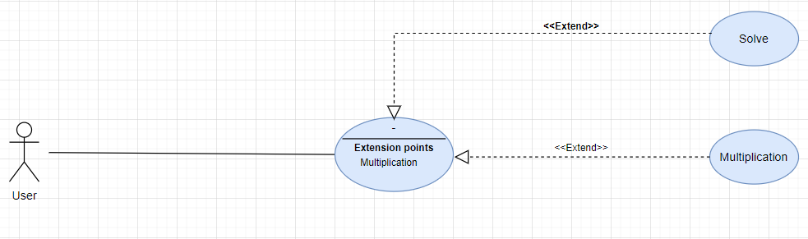

1. Use Case Specification

| Use case ID | UC.03 | | | | |
| --- | --- | --- | --- | --- | --- |
| Use case name | **Nhân 2 số bất kỳ** | | | | |
| Create by | Nguyễn Quang Thông | | **Last updated by** | | Nguyễn Quang Thông |
| Date created | Jannuary 26, 2024 | | **Date last updated** | | January 27, 2024 |
| Actor | Users of the system | | | | |
| Description | This Use Case describes the process of adding two arbitrary numbers within the system. | | | | |
| Trigger | Access to the system interface successfully | | | | |
| Pre-condition | **Both values entered are numeric** | | | | |
| Post-condition | If the use case is successful, the system displays the result of adding the two numbers on the user interface. | | | | |
| Main Success | **Step** | **Actor Action** | | **System Response** | |
| Scenario | 1 | Press the "Multiplication" button | | 2. The system displays a box for the user to enter 2 numbers | |
| 3 | The user enters 2 numbers into the box | | 4. The system confirms the number the user entered | |
| 5 | Press the "solve" button | | 6. Check the correct data type, the system displays the results to the user | |
| 7 |  | | 8. Display the total results on the screen | |
| Exception | **Step** | **Actor Action** | | **System Response** | |
|  |  | | 6.1 If the data type is checked incorrectly, the system will notify the error and let the user re-enter the number. | |
| Priority | High | | | | |
| Business rule | N/A | | | | |
| Description: | The addition function for two numbers is a fundamental mathematical and programming operation used to increase the value of two numbers together. The main purpose of addition is to aggregate the values of the given numbers. | | | | |

##### UC.04: Division

1. Use Case Diagram

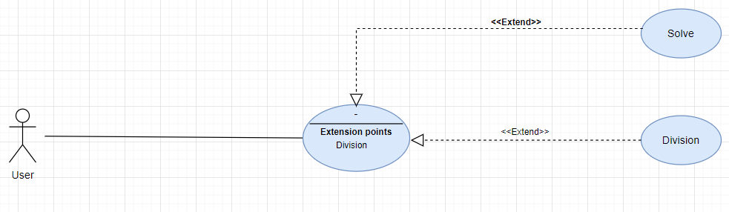

1. Use Case Specification

| Use case ID | UC.04 | | | | |
| --- | --- | --- | --- | --- | --- |
| Use case name | **Chia 2 số bất kỳ** | | | | |
| Create by | Nguyễn Quang Thông | | **Last updated by** | | Nguyễn Quang Thông |
| Date created | Jannuary 26, 2024 | | **Date last updated** | | January 27, 2024 |
| Actor | Users of the system | | | | |
| Description | This Use Case describes the process of adding two arbitrary numbers within the system. | | | | |
| Trigger | Access to the system interface successfully | | | | |
| Pre-condition | **Both values entered are numeric** | | | | |
| Post-condition | If the use case is successful, the system displays the result of adding the two numbers on the user interface. | | | | |
| Main Success | **Step** | **Actor Action** | | **System Response** | |
| Scenario | 1 | Press the "Division" button | | 2. The system displays a box for the user to enter 2 numbers | |
| 3 | The user enters 2 numbers into the box | | 4. The system confirms the number the user entered | |
| 5 | Press the "solve" button | | 6. Check the correct data type, the system displays the results to the user | |
| 7 |  | | 8. Display the total results on the screen | |
| Exception | **Step** | **Actor Action** | | **System Response** | |
|  |  | | 6.1 If the data type is checked incorrectly, the system will notify the error and let the user re-enter the number. | |
| Priority | High | | | | |
| Business rule | N/A | | | | |
| Description: | The addition function for two numbers is a fundamental mathematical and programming operation used to increase the value of two numbers together. The main purpose of addition is to aggregate the values of the given numbers. | | | | |

##### UC.05: Mode

1. Use Case Diagram

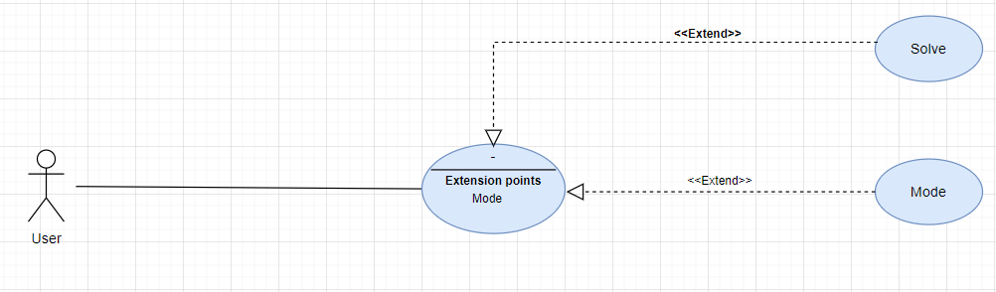

1. Use Case Specification

| Use case ID | UC.05 | | | | |
| --- | --- | --- | --- | --- | --- |
| Use case name | **Chia 2 số bất kỳ lấy dư** | | | | |
| Create by | Nguyễn Quang Thông | | **Last updated by** | | Nguyễn Quang Thông |
| Date created | Jannuary 26, 2024 | | **Date last updated** | | January 27, 2024 |
| Actor | Users of the system | | | | |
| Description | This Use Case describes the process of adding two arbitrary numbers within the system. | | | | |
| Trigger | Access to the system interface successfully | | | | |
| Pre-condition | **Both values entered are numeric** | | | | |
| Post-condition | If the use case is successful, the system displays the result of adding the two numbers on the user interface. | | | | |
| Main Success | **Step** | **Actor Action** | | **System Response** | |
| Scenario | 1 | Press the "Mode" button | | 2. The system displays a box for the user to enter 2 numbers | |
| 3 | The user enters 2 numbers into the box | | 4. The system confirms the number the user entered | |
| 5 | Press the "solve" button | | 6. Check the correct data type, the system displays the results to the user | |
| 7 |  | | 8. Display the total results on the screen | |
| Exception | **Step** | **Actor Action** | | **System Response** | |
|  |  | | 6.1 If the data type is checked incorrectly, the system will notify the error and let the user re-enter the number. | |
| Priority | High | | | | |
| Business rule | N/A | | | | |
| Description: | The addition function for two numbers is a fundamental mathematical and programming operation used to increase the value of two numbers together. The main purpose of addition is to aggregate the values of the given numbers. | | | | |

## 2.4.6 . Activity Diagrams

## Addition

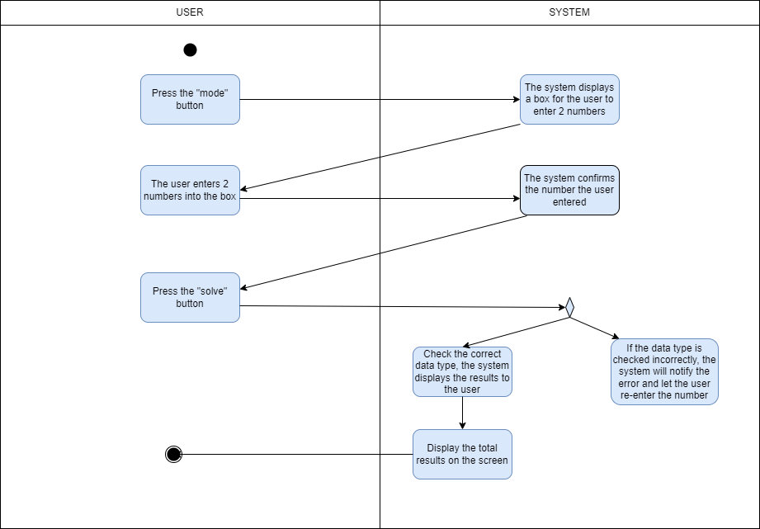

## Subtraction

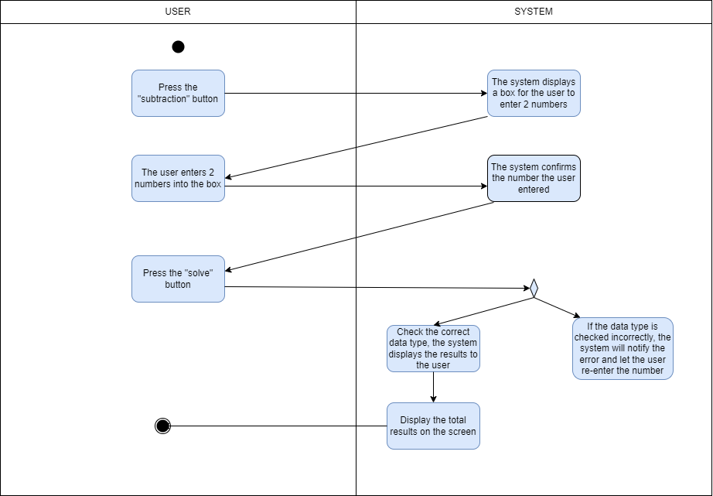

## Multiplication

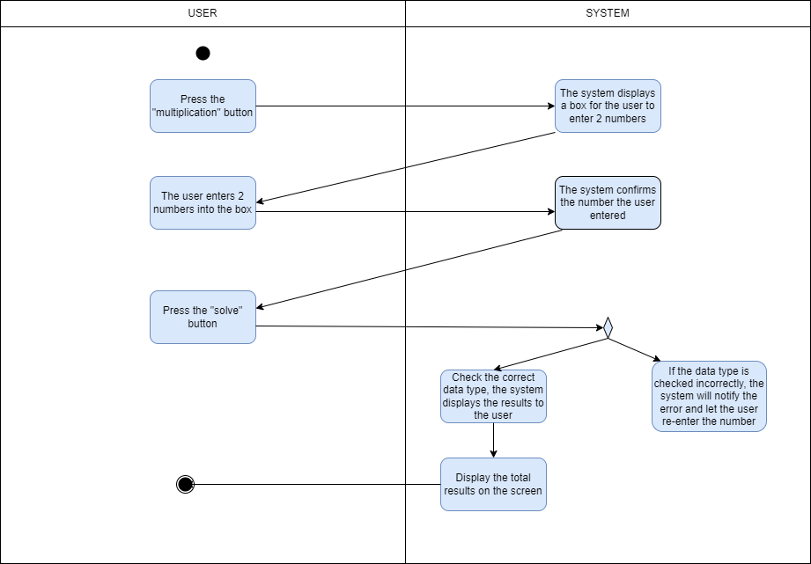

## Division

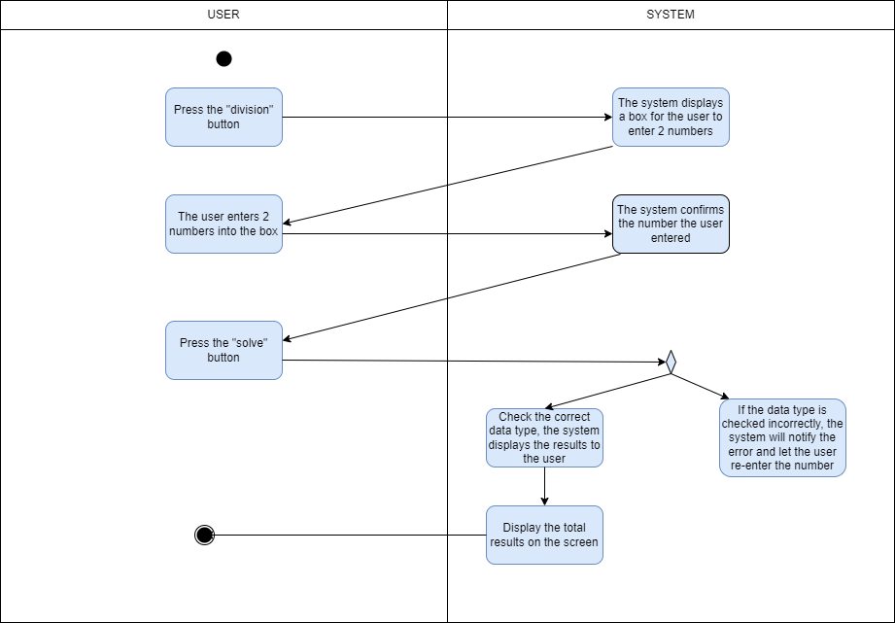

## Mode



# Appendix A: Glossary

| FR | Functional Requirement |
| --- | --- |
| QA | Quality Attribute |
| UC | Use case |
| BR | Business rule |